# Insert review title#: a systematic review protocol
Primary reviewer name¹
Secondary reviewer name²
1 Primary reviewer affiliation
2 Secondary reviewer affiliation

Corresponding author:
Reviewer name
Email: xx@xx.xx.xx

Review question/objective
The quantitative objective/s is/are to identify the effectiveness of #state intervention# on #state outcome#
More specifically, the objectives are to identify the effectiveness of #insert text# on #insert text# in #insert text#
The qualitative objective/s is/are to identify the meaningfulness/appropriateness of #modify text as appropriate# of #phenomena of interest#.
The textual objective/s is/are to identify the findings of #describe#
The economic objective/s of this review is/are to identify the cost effectiveness, cost benefit, cost minimization, cost utility #modify text as appropriate# of #state intervention# on #state outcome#
More specifically, the objectives are to identify the evidence on:
The cost effectiveness, cost benefit, cost minimization, cost utility #modify text as appropriate# of #insert text# compared to #insert text# on #insert text# in #insert text#

Background
#Insert text; approximately 1000 words#
Subheadings (if required)

Keywords

List each keyword separated with a semi colon and space

Inclusion criteria
Types of participants
This review will consider studies that include #describe participants#
Types of intervention(s)/phenomena of interest
This review will consider studies that evaluate #insert text#
Types of outcomes
This review will consider studies that include the following outcomes #insert text#
Types of studies
The quantitative component of the review will consider both experimental and epidemiological study designs including randomized controlled trials, non-randomized controlled trials, quasi-experimental studies, before and after studies, prospective and retrospective cohort studies, case control studies and analytical cross sectional studies #modify text as appropriate# for inclusion.The quantitative component of the review will also consider descriptive epidemiological study designs including case series, individual case reports and descriptive cross sectional studies #modify text as appropriate# for inclusion.
The qualitative component of the review will consider studies that focus on qualitative data including, but not limited to, designs such as phenomenology, grounded theory, ethnography, action research and feminist research.
In the absence of research studies, other text such as opinion papers and reports will be considered. If you wish to include opinion papers and reports select textual evidence and the NOTARI analytical Module and then select to insert set text now. The textual component of the review will consider expert opinion, discussion papers, position papers and other text.
The economic component of the review will consider cost effectiveness, cost benefit, cost minimization, cost utility #modify text as appropriate# studies.

Search strategy
The search strategy aims to find both published and unpublished studies. A three-step search strategy will be utilized in this review. An initial limited search of MEDLINE and CINAHL #change as appropriate# will be undertaken followed by an analysis of the text words contained in the title and abstract, and of the index terms used to describe article. A second search using all identified keywords and index terms will then be undertaken across all included databases. Thirdly, the reference list of all identified reports and articles will be searched for additional studies. Studies published in #insert language(s)# will be considered for inclusion in this review. Studies published #insert dates# will be considered for inclusion in this review.
The databases to be searched include:
#insert text#
The search for unpublished studies will include:
#insert text#
Initial keywords to be used will be:
#insert text#

Assessment of methodological quality
Papers selected for retrieval will be assessed by two independent reviewers for methodological validity prior to inclusion in the review using standardized critical appraisal instruments from the Joanna Briggs Institute Meta-Analysis of Statistics Assessment and Review Instrument (JBI-MAStARI) (Appendix I). Any disagreements that arise between the reviewers will be resolved through discussion, or with a third reviewer.
Qualitative papers selected for retrieval will be assessed by two independent reviewers for methodological validity prior to inclusion in the review using standardized critical appraisal instruments from the Joanna Briggs Institute Qualitative Assessment and Review Instrument (JBI-QARI) (Appendix I). Any disagreements that arise between the reviewers will be resolved through discussion, or with a third reviewer.
Textual papers selected for retrieval will be assessed by two independent reviewers for authenticity prior to inclusion in the review using standardized critical appraisal instruments from the Joanna Briggs Institute Narrative, Opinion and Text Assessment and Review Instrument (JBI-NOTARI) (Appendix I). Any disagreements that arise between the reviewers will be resolved through discussion, or with a third reviewer.
Economic papers selected for retrieval will be assessed by two independent reviewers for methodological validity prior to inclusion in the review using standardized critical appraisal instruments from the Joanna Briggs Institute Analysis of Cost, Technology and Utilization Assessment and Review Instrument (JBI-ACTUARI) (Appendix I). Any disagreements that arise between the reviewers will be resolved through discussion, or with a third reviewer.

Data extraction
Quantitative data will be extracted from papers included in the review using the standardised data extraction tool from JBI-MAStARI (Appendix II). The data extracted will include specific details about the interventions, populations, study methods and outcomes of significance to the review question and specific objectives.
Qualitative data will be extracted from papers included in the review using the standardised data extraction tool from JBI-QARI (Appendix II). The data extracted will include specific details about the interventions, populations, study methods and outcomes of significance to the review question and specific objectives.
Textual data will be extracted from papers included in the review using the standardised data extraction tool from JBI-NOTARI (Appendix II). The data extracted will include specific details about the interventions, populations, study methods and outcomes of significance to the review question and specific objectives.
Economic data will be extracted from papers included in the review using the standardised data extraction tool from JBI-ACTUARI (Appendix II). The data extracted will include specific details about the interventions, populations, study methods and outcomes of significance to the review question and specific objectives.

Data synthesis
Quantitative data will, where possible be pooled in statistical meta-analysis using JBI-MAStARI. All results will be subject to double data entry. Effect sizes expressed as odds ratio (for categorical data) and weighted mean differences (for continuous data) and their 95% confidence intervals will be calculated for analysis #modify text as appropriate#. Heterogeneity will be assessed statistically using the standard Chi-square and also explored using subgroup analyses based on the different study designs included in this review. Where statistical pooling is not possible the findings will be presented in narrative form including tables and figures to aid in data presentation where appropriate.

Conflicts of interest
#insert text#

Acknowledgements
#insert text#

References
1. Rorabeck CH. The treatment of compartment syndromes of the leg. J Bone Joint Surg Br. 1984;66(1):93-7.
2. McQueen MM, Court-Brown CM. Compartment monitoring in tibial fractures. The pressure threshold for decompression. J Bone Joint Surg Br. 1996;78(1):99-104.
3. Bourne RB, Rorabeck CH. Compartment syndromes of the lower leg. Clin Orthop Relat Res. 1989(240):97-104.
4. Sheridan GW, Matsen FA, 3rd. Fasciotomy in the treatment of the acute compartment syndrome. J Bone Joint Surg Am. 1976;58(1):112-5.
5. Finkelstein JA, Hunter GA, Hu RW. Lower limb compartment syndrome: course after delayed fasciotomy. J Trauma. 1996;40(3):342-4.
6. McQueen M. Acute compartment syndrome. Acta Chir Belg. 1998;98(4):166-70.
7. Fitzgerald AM, Gaston P, Wilson Y, Quaba A, McQueen MM. Long-term sequelae of fasciotomy wounds. Br J Plast Surg. 2000;53(8):690-3.
8. Giannoudis PV, Nicolopoulos C, Dinopoulos H, Ng A, Adedapo S, Kind P. The impact of lower leg compartment syndrome on health related quality of life. Injury. 2002;33(2):117-21.
9. Velmahos GC, Theodorou D, Demetriades D, Chan L, Berne TV, Asensio J, et al. Complications and nonclosure rates of fasciotomy for trauma and related risk factors. World J Surg. 1997;21(3):247-52; discussion 53.
10. Blackman PG. A review of chronic exertional compartment syndrome in the lower leg. Med Sci Sports Exerc. 2000;32(3 Suppl):S4-10.
11. Rorabeck CH, Fowler PJ, Nott L. The results of fasciotomy in the management of chronic exertional compartment syndrome. Am J Sports Med. 1988;16(3):224-7.
12. Ojike NI, Roberts CS, Giannoudis PV. Compartment syndrome of the thigh: a systematic review. Injury. 2010;41(2):133-6.
Insert page break

Appendix I: Appraisal instruments
MAStARI appraisal instrument
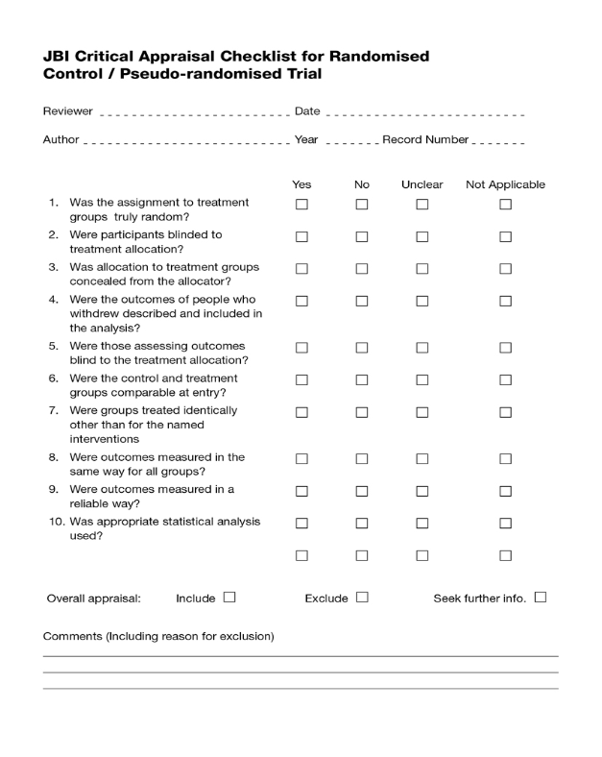

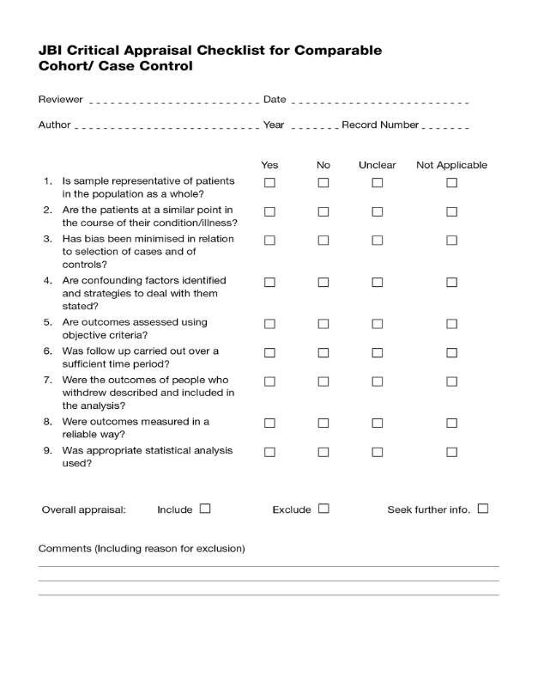
QARI appraisal instrument
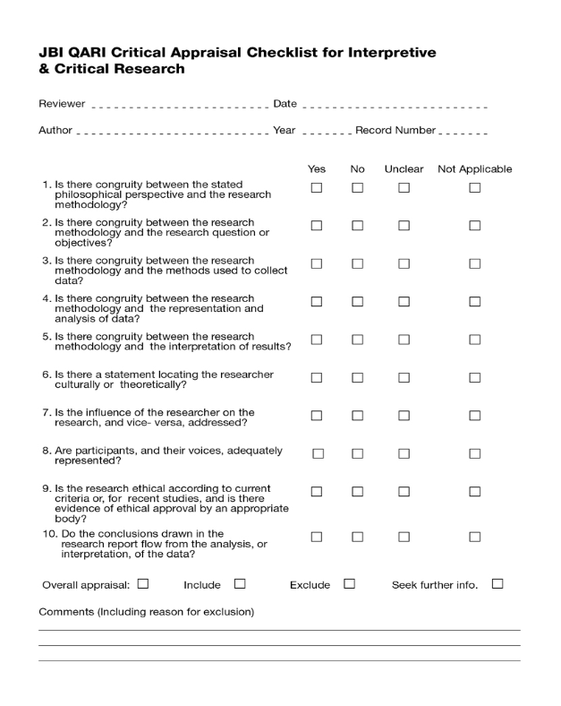
ACTUARI appraisal instrument

NOTARI appraisal instrument


Appendix II: Data extraction instruments
MAStARI data extraction instrument
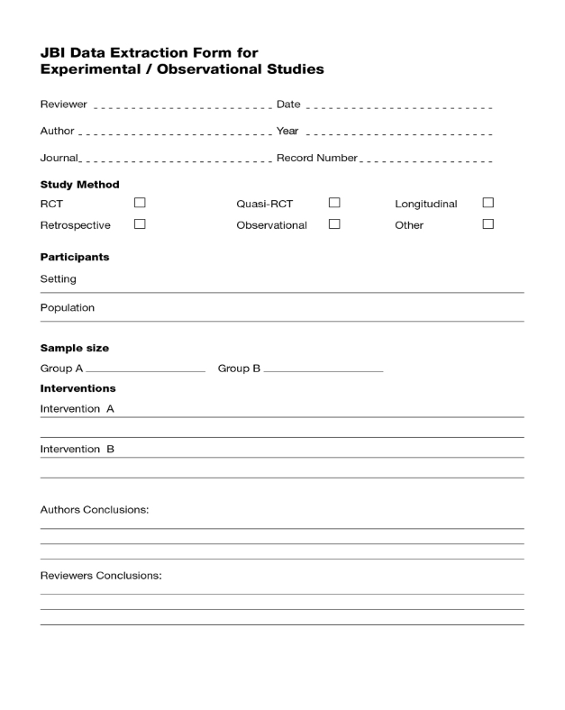
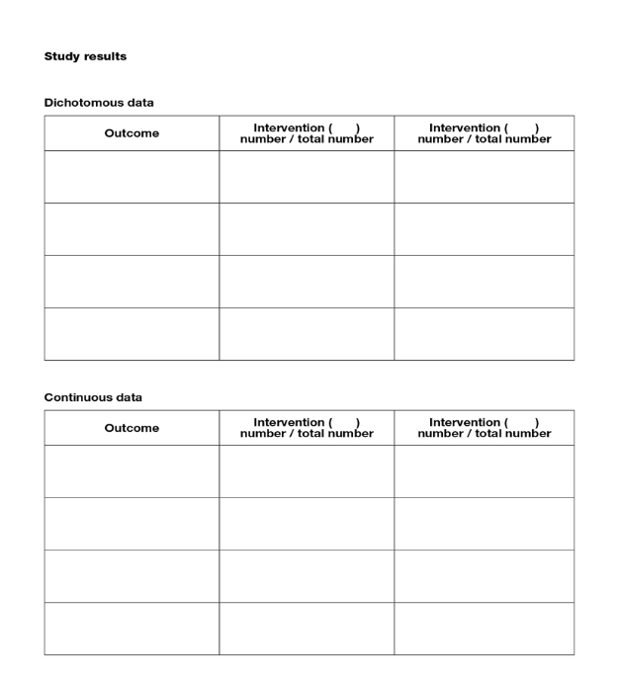
QARI data extraction instrument
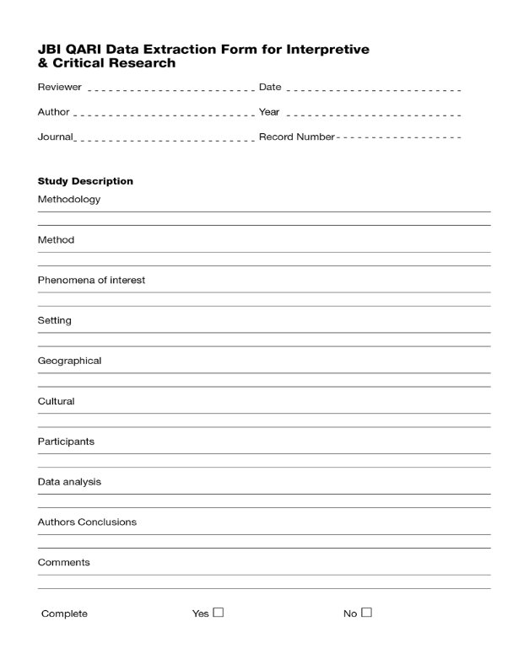
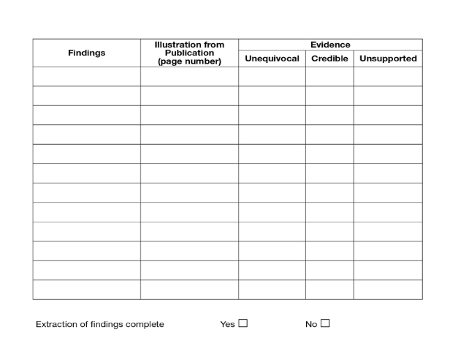
ACTUARI data extraction instrument
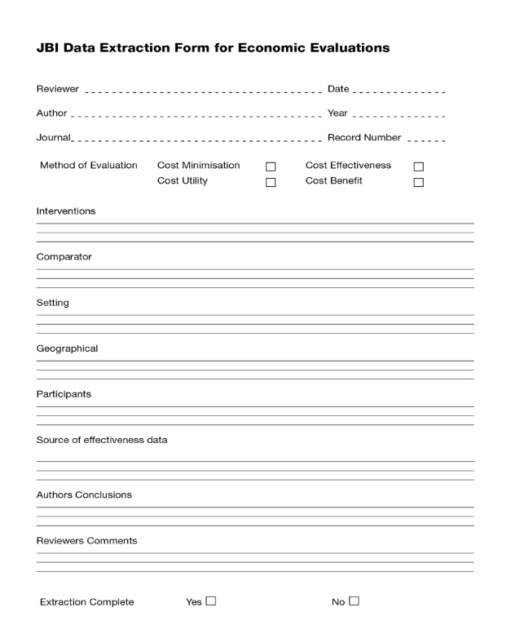
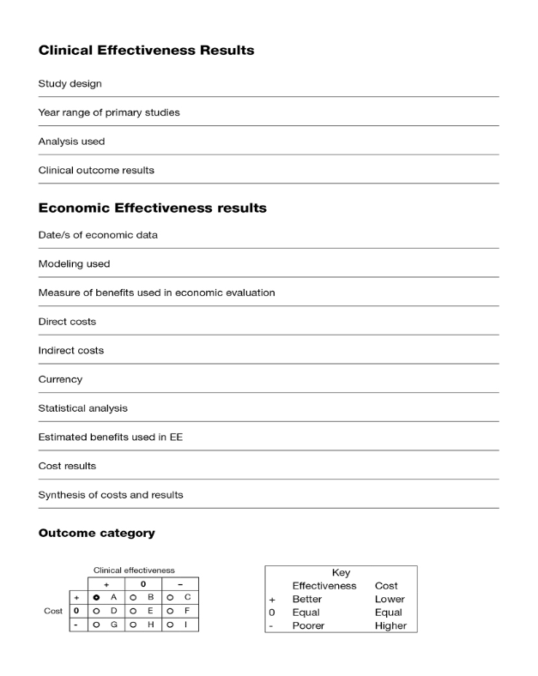
NOTARI data extraction instrument
