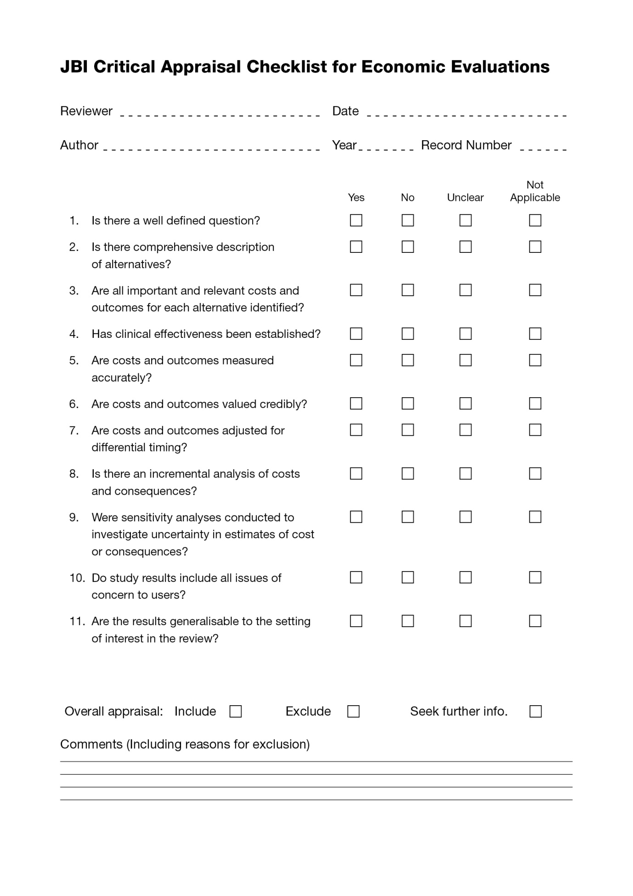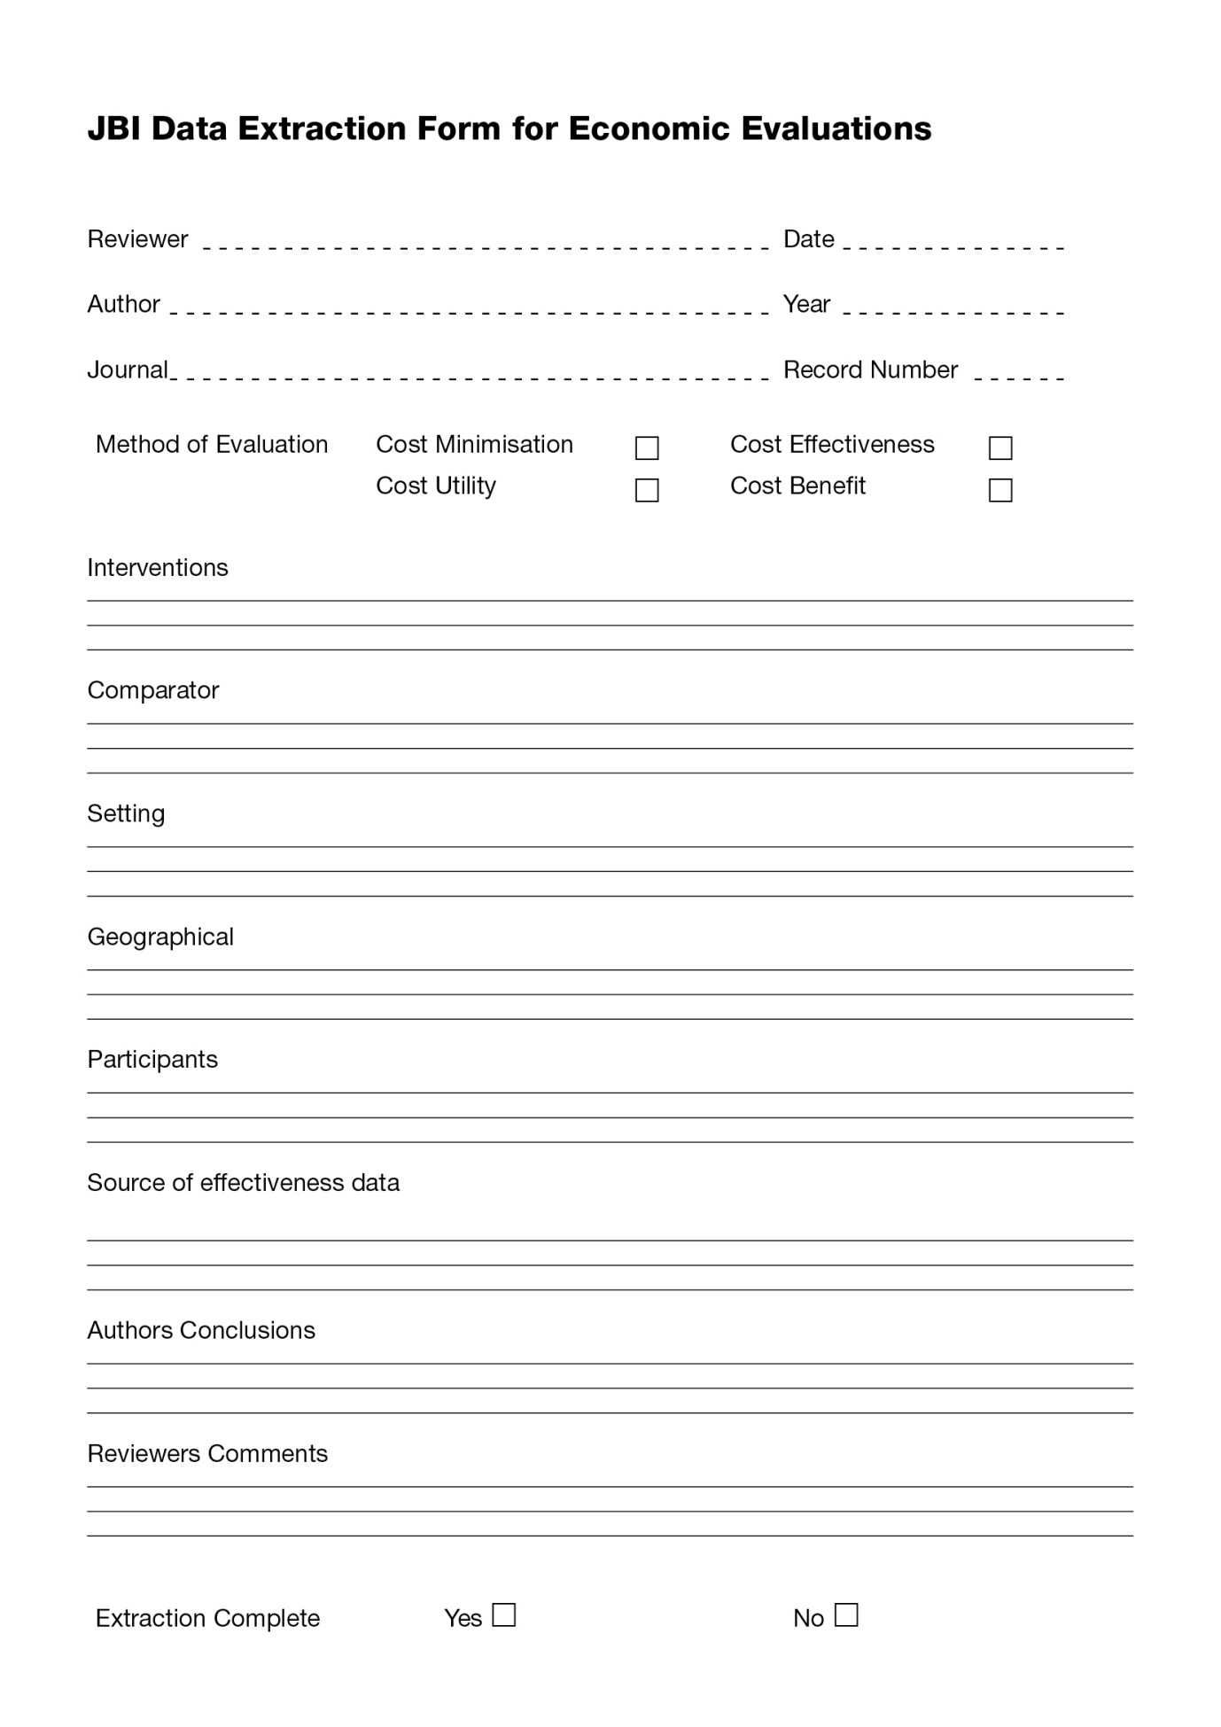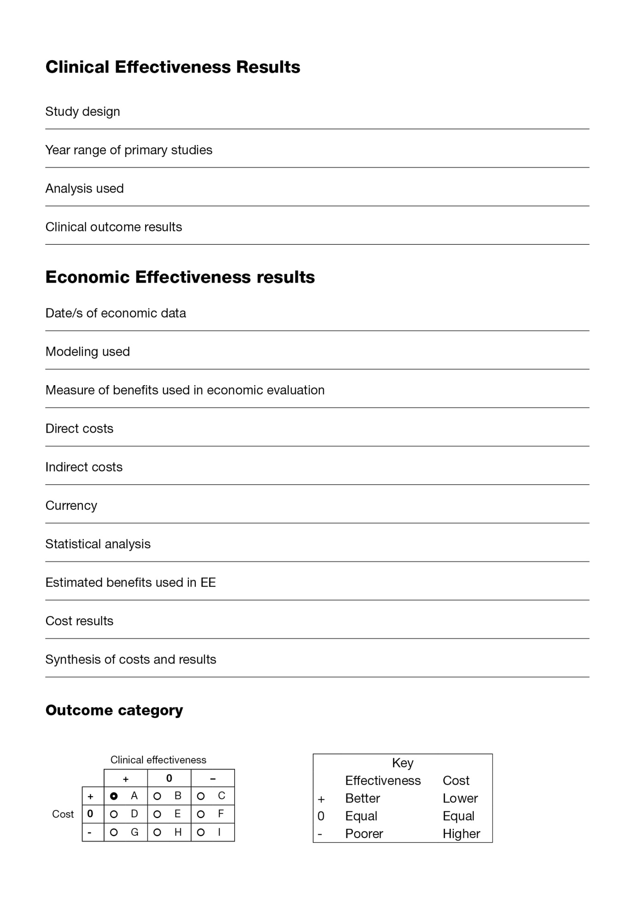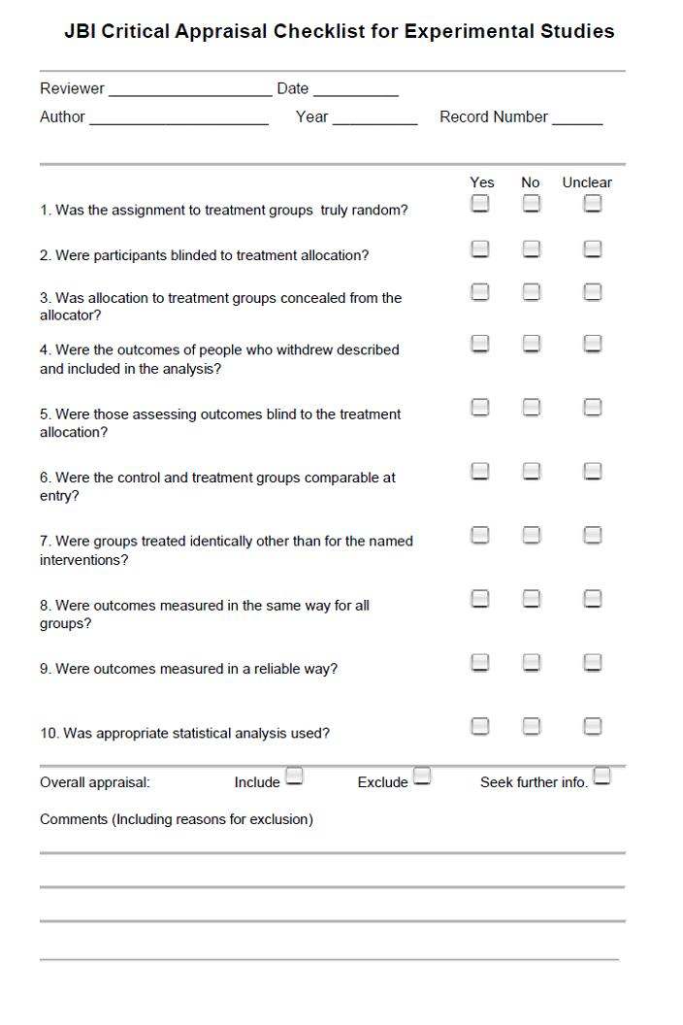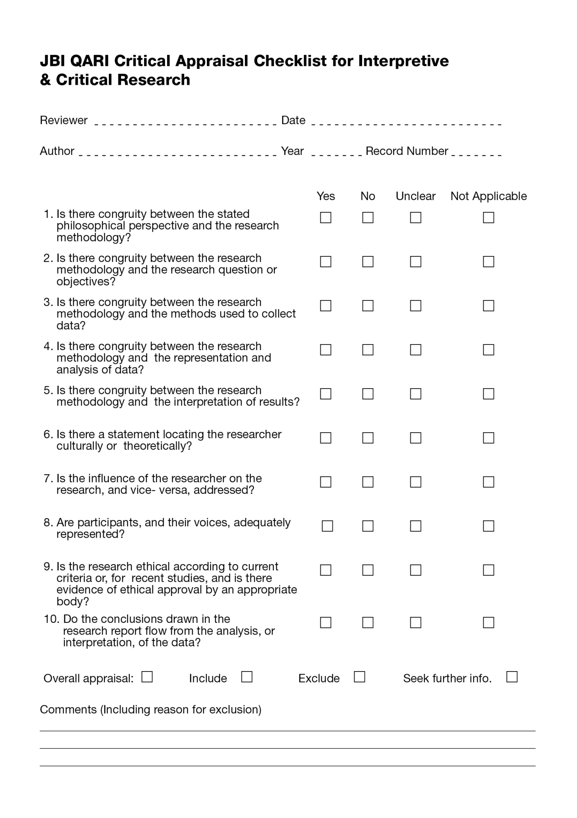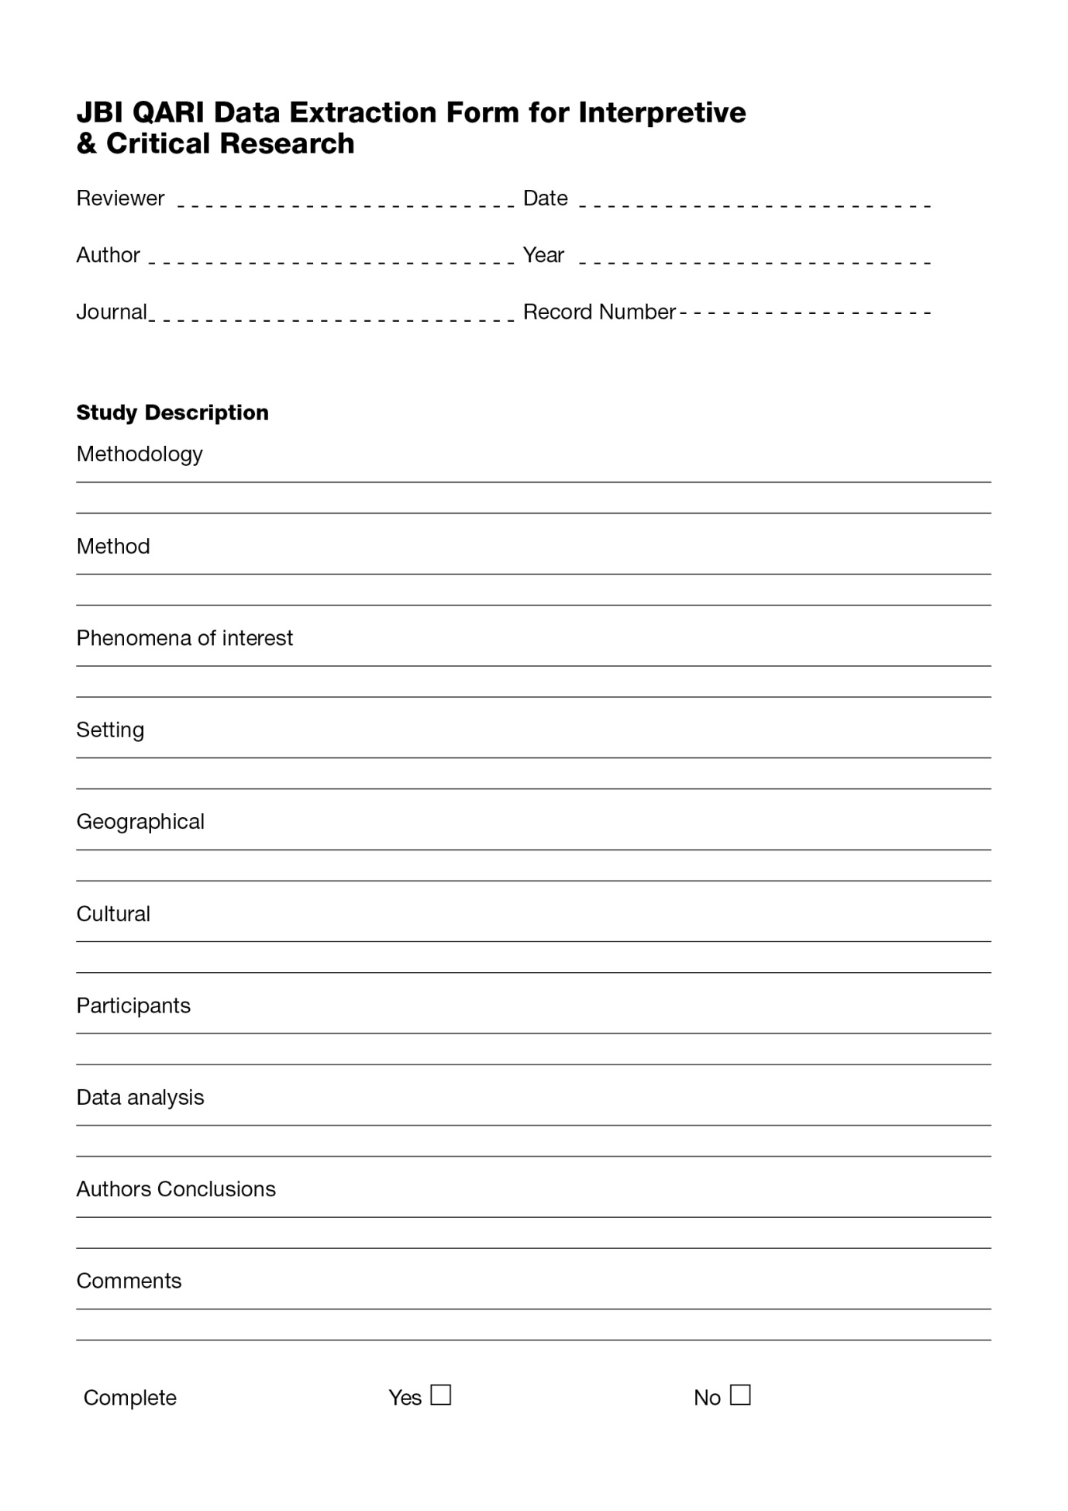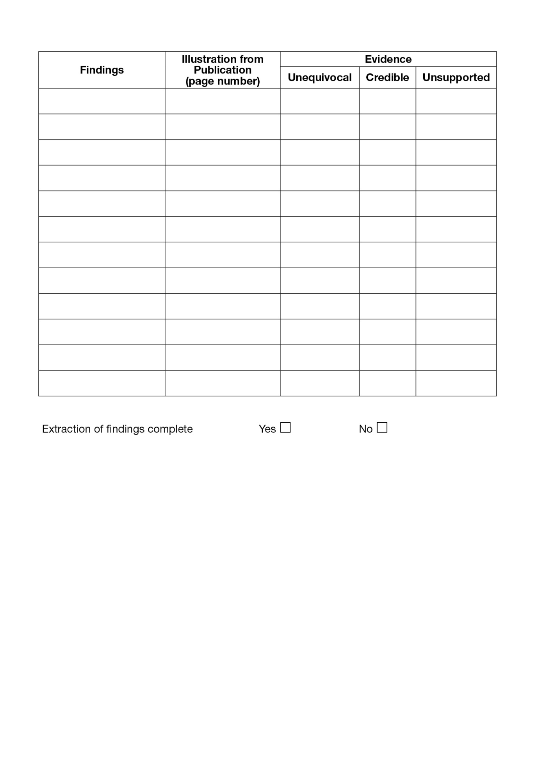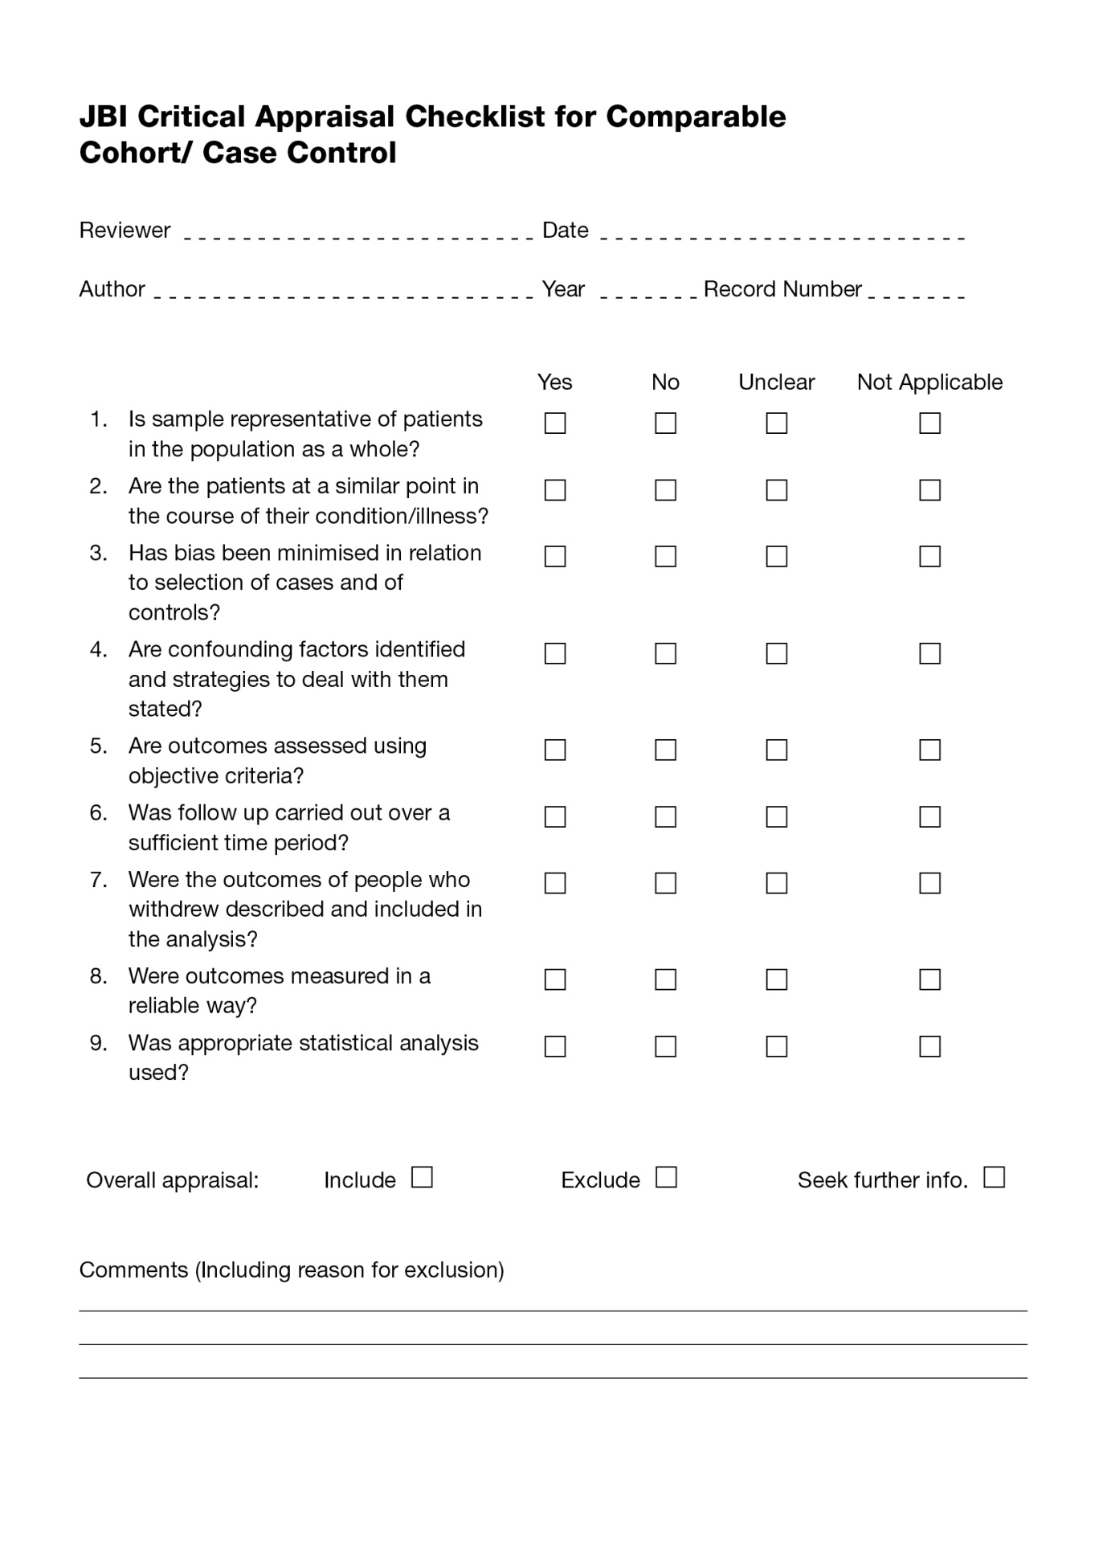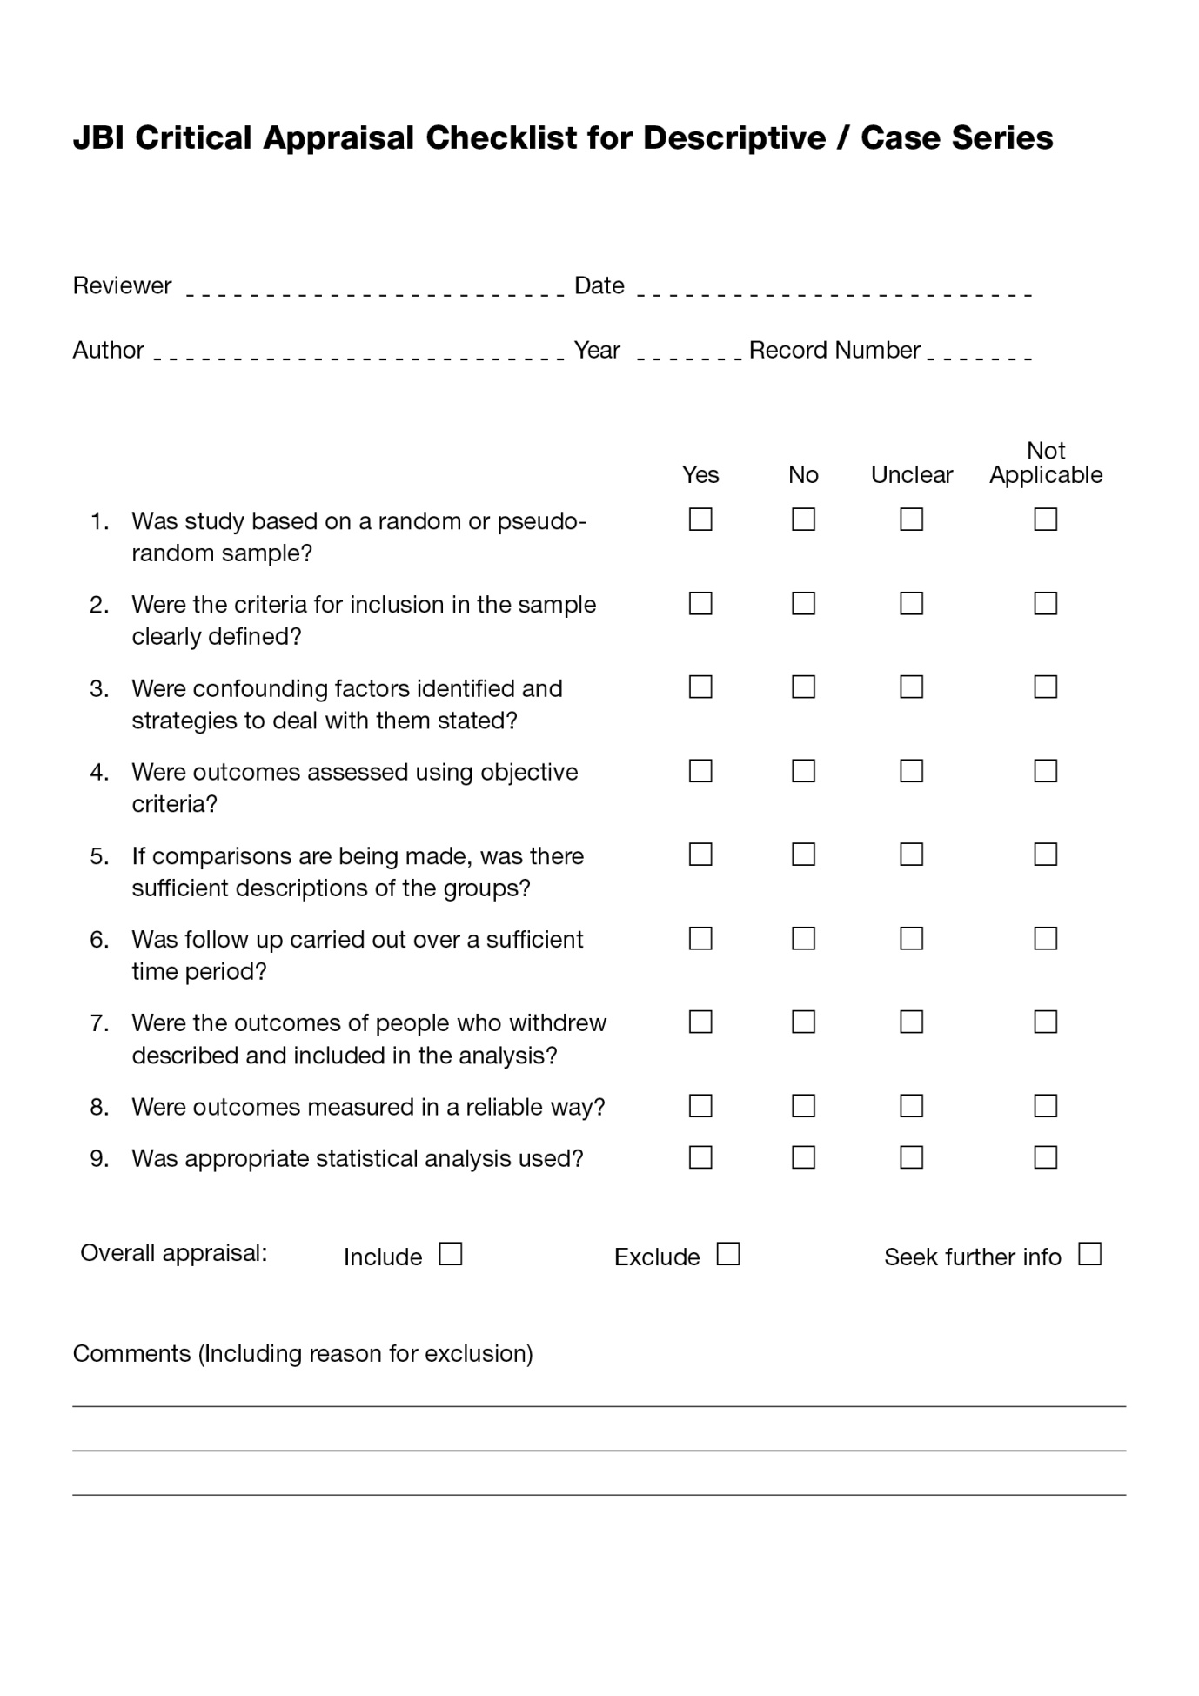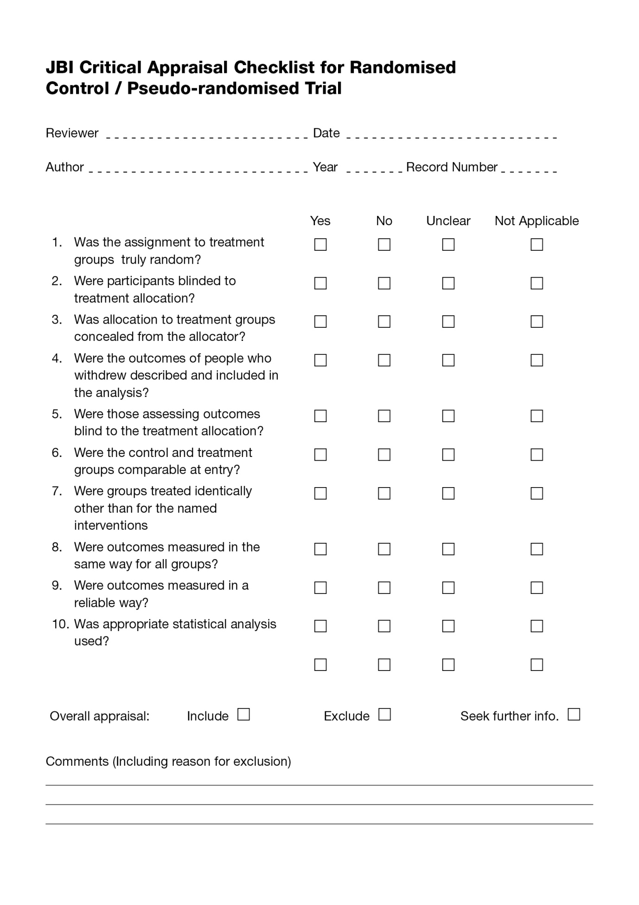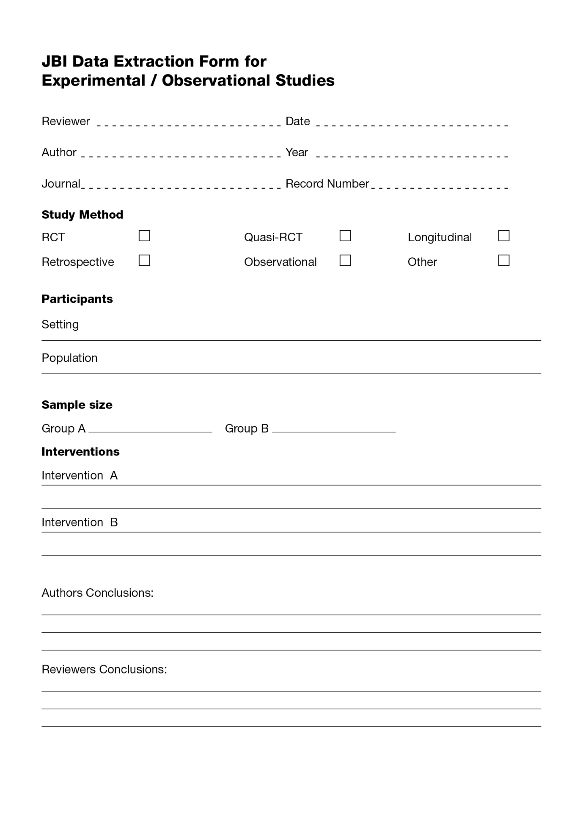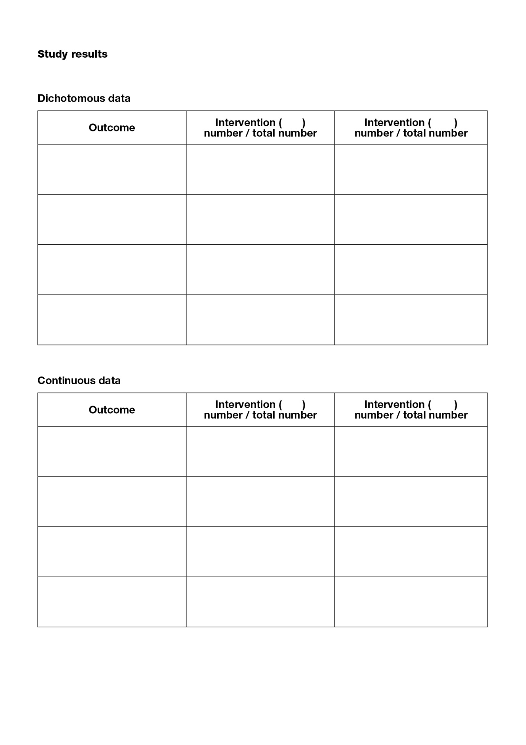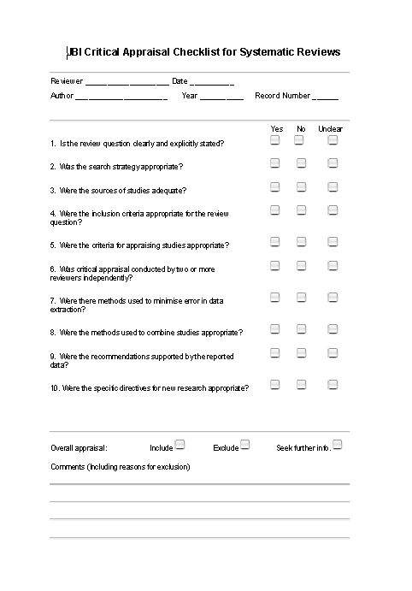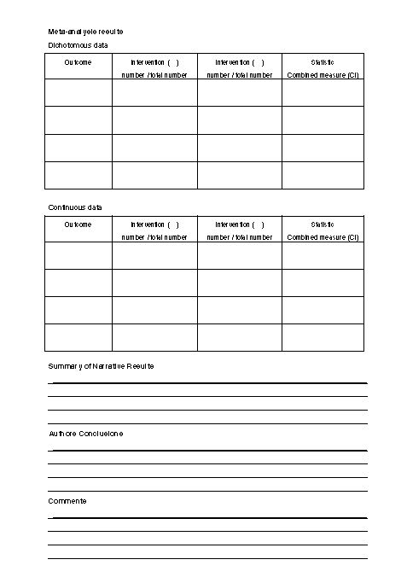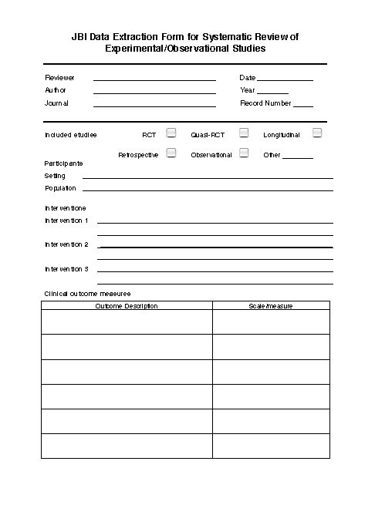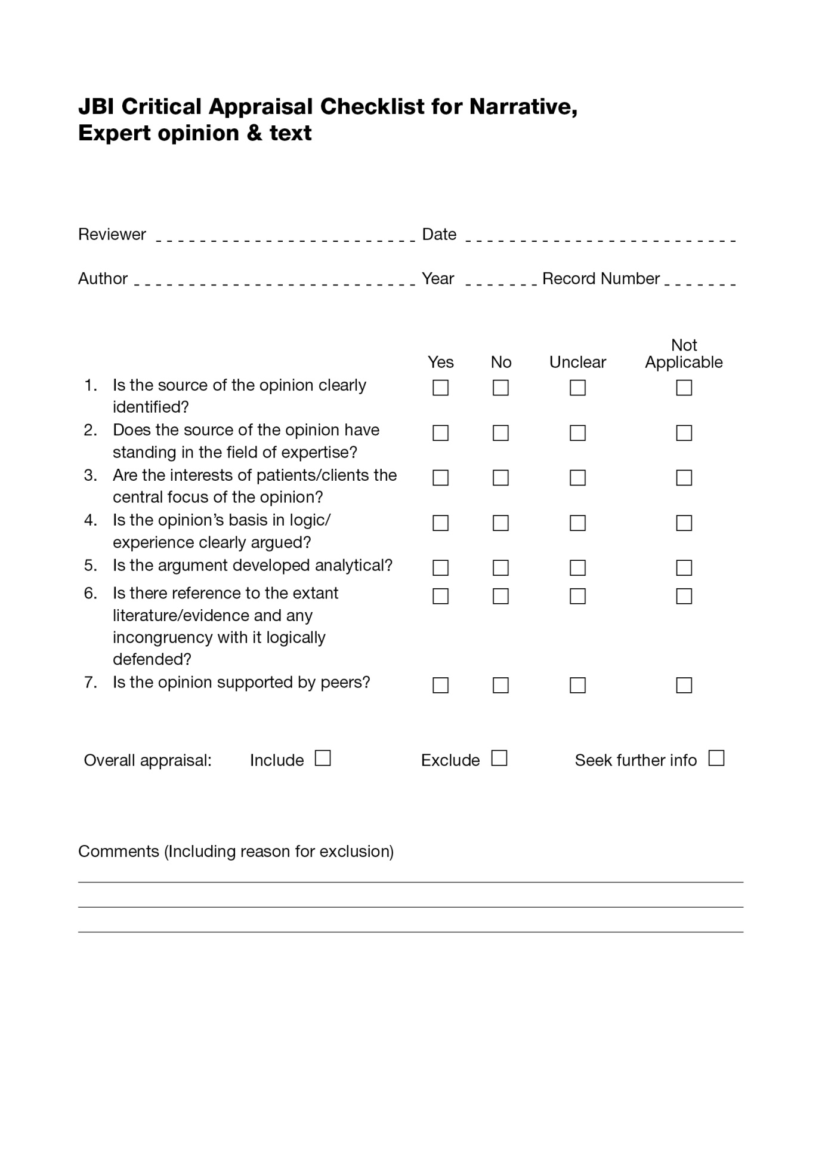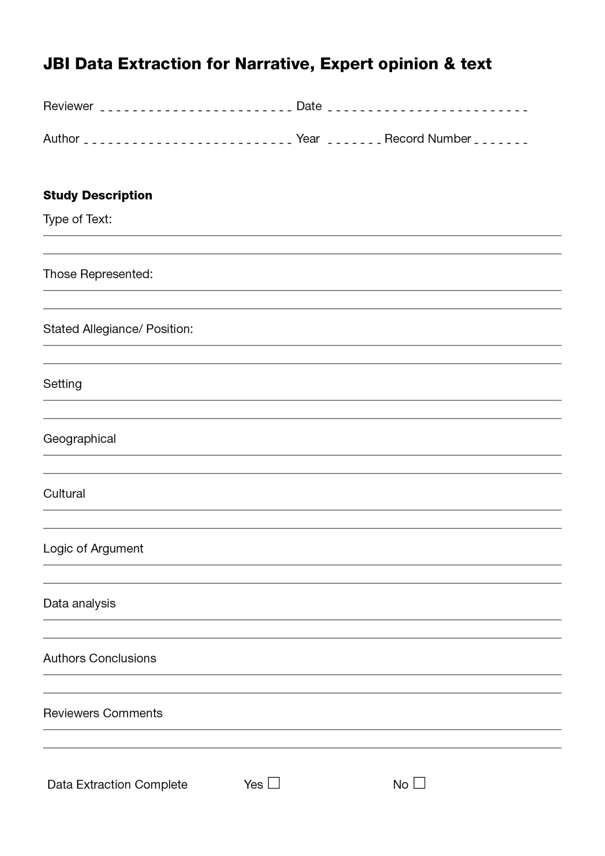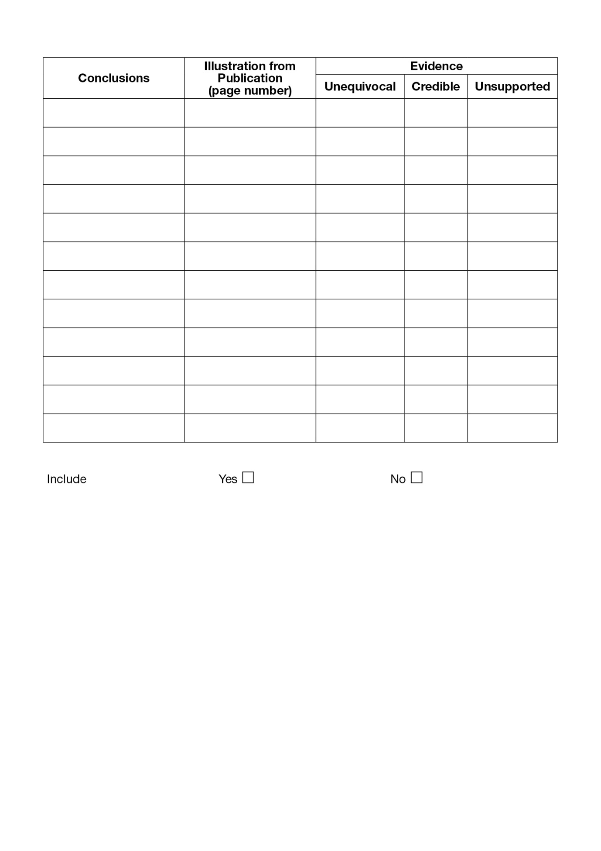

JBI Critical Appraisal Checklist for Systematic Reviews and Research Syntheses
Reviewer Date
Author Year Record Number
 | Yes | No | Unclear | Not applicable
- Is the review question clearly and explicitly stated?

- Were the inclusion criteria appropriate for the review question?

- Was the search strategy appropriate?

- Were the sources and resources used to search for studies adequate?

- Were the criteria for appraising studies appropriate?

- Was critical appraisal conducted by two or more reviewers independently?

- Were there methods to minimize errors in data extraction?

- Were the methods used to combine studies appropriate?

- Was the likelihood of publication bias assessed?

- Were recommendations for policy and/or practice supported by the reported data?

- Were the specific directives for new research appropriate?

Overall appraisal: Include Exclude Seek further info

JBI Data Extraction Form for Review for Systematic Reviews and Research Syntheses
- What are effective non-pharmacological interventions to manage aggressive behavior in elderly patients with dementia?
- What are the experiences of dementia patients and their caregivers with the use of non-pharmacological interventions to manage aggressive behavior?
Study Details
Author/year
objectives
Participants (characteristics/total number)
Setting/context
Description of Interventions/ phenomena of interest
Search Details
Sources searched
Range (years) of incl studies
Number of studies included /
Types of studies included
Country of origin of incl. studies
Appraisal
Appraisal instruments used
Appraisal rating
Analysis
Method of analysis
Outcome assessed
Results/Findings
Significance/direction

JBI Critical Appraisal Checklist for Studies Reporting Prevalence Data
Reviewer Date
Author Year Record Number
 | Yes | No | Unclear | Not applicable
- Was the sample representative of the target population?

- Were study participants recruited in an appropriate way?

- Was the sample size adequate?

- Were the study subjects and the setting described in detail?

- Was the data analysis conducted with sufficient coverage of the identified sample?

- Were objective, standard criteria used for the measurement of the condition?

- Was the condition measured reliably?

- Was there appropriate statistical analysis?

- Are all important confounding factors/ subgroups/ differences identified and accounted for?

- Were subpopulations identified using objective criteria?

Overall appraisal: Include Exclude Seek further info

